***Java Features***

1. **Write minimum five statements about Java?**

**Ans: - i.** Java is a general purpose programming language that is class based ,object oriented and designed to have as few implementation depends as possible.

**ii.** Java was 1st developed by Jams Gosling.

**iii.**  At 1st java is the product of Sun Micro System, but now it is a product of ORACLE.

iv. Java is a Platform Independent language i.e. Java is executed in different operating system.

v. Java provides open source i.e. JDK (Java Developing kit) is not restricted within Sun Micro System or ORACLE .But it is freely available for any user.

**2) What are the Application areas of Java?**

**Ans: -** Application areas of Java are :

1. SE(Standard Edition)
2. EE(Enterprise Edition)
3. ME(Micro Edition)
4. Framework

3) Difference between System software and Application software?

Ans**: -**System Software is used for operating computer hardware. On other hand Application Software is used by user to perform specific task. System Software are installed on the computer when Operating System is installed. On other hand in Application Software can’t run independently.

**4) Give some example of Object-Oriented language?**

**Ans: -** Some Object-Oriented language are :-

**i.** Java

**ii.** C++

**iii.** C#

**5) Difference between Procedure Oriented and Object Oriented program?**

**Ans: -** Procedure oriented programming(POP) Supports Top-Down approach whereas Object Oriented Programming (OOP) Supports bottom-up approach

POP supports Inheritance, Polymorphism, Abstraction, Encapsulation, and Association. Whereas OOP supports all the concepts of Object Oriented standard.

**6) List of features added in latest version of java?**

**Ans:-**

**7) What are the features not supported in Java comparing to C/C++?**

**Ans: -** Keywords like const or goto or structure or union are not support in Java. Also pointers are not supported in Java. Java does not support storage classes.

**8. What are the features of Java?**

**Ans: -** java features are:

1. Object Oriented
2. Jshell
3. Secure
4. Robust
5. Platform Independent
6. Secure
7. Robust

**9) Explain how java is open source?**

Ans: - The source code at JDK (Java developing kit) is not restricted within Sun micro System or Oracle but it is freely available for any user. So, Java is open source.

**10) Explain the importance of platform independent?**

Ans: - Platform independent means the execution of the program is not restricted by any type of operating system installed and hence we can execute the program any type of Operating System, which mean once written we can run it anywhere. Java is also a Platform Independent Language.

**11) How Java is secure language?**

Ans: - Java compiler converts the Java code into byte code (.class file) and these byte codes are run by Java Virtual Machine (JVM). When this byte codes are executed, the JVM can take care of the security.

**12) Define the use of var in Java.**

Ans: - VAr concept is newly introduced in java language. Which is use to replace the data types.

e.g.: - class test

{

Public static void main(String[] args)

{

Var a=10;

Var b=”Hello”;

}

}

In this example the variable ‘a’ by default is a integer type data and variable ‘b’ by default is a String type.

**13) What is the importance of JShell implementation in java?**

Ans: - The Java Shell tool (JShell) is an interactive tool for learning the Java programming language and prototyping Java code. JShell is a Read-Evaluate-Print Loop (REPL), which evaluates declarations, statements, and expressions as they are entered and immediately shows the results. The tool is run from the command line.

**14) State the difference between JDK and JRE?**

Ans: -

**[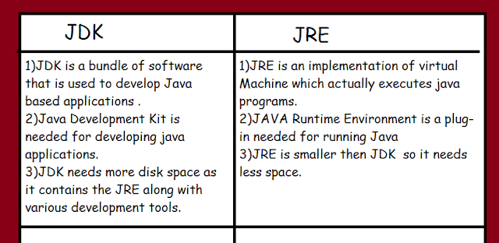](https://1.bp.blogspot.com/-2N8bkht4A0c/WD0pTHrSb3I/AAAAAAAACaY/YyX70X_2gg0hdWSlogEWAT57F7x9k53VQCLcB/s1600/jdk.png)**

**15) How to set the path?**

Ans: - There are two ways to set the path in Java:

1. Temporary using command prompt.
2. Permanently using environment variables.

**16) Explain, how to create a single File Application?**

Ans: - To create a single File Application the syntax is:

Java filename.java

This feature allows executing your java source code directly using the Java interpreter. The source code compiled in memory and then executed by the interpreter.  
**17) Java is robust, how?**

Ans: - Java is robust because: -

1. It uses strong memory management.
2. There is absence of pointers that bypass security problem.

**18) Explain how Java is Architectural Neutral?**

Ans: - The java compiler compile by generating byte code, which have nothing to do with particular computer architecture. Rather, they are designed to be both easy to interpret on any machine and easily translated into native machine code on the fly.

**19) What is Byte code and its importance?**

Ans: - Byte code is program code that has been compiled from source code into low-level code designed for a software interpreter.

Java byte code is the machine code in the form of .class file.

With the help of byte code, we archive platform independence in java.

**20) Who makes Java platform independent and how?**

Ans: - JVM makes Java platform independent, because the result of the java compiler is .class file or byte code. JVM can execute it.